DONALD WIEDER

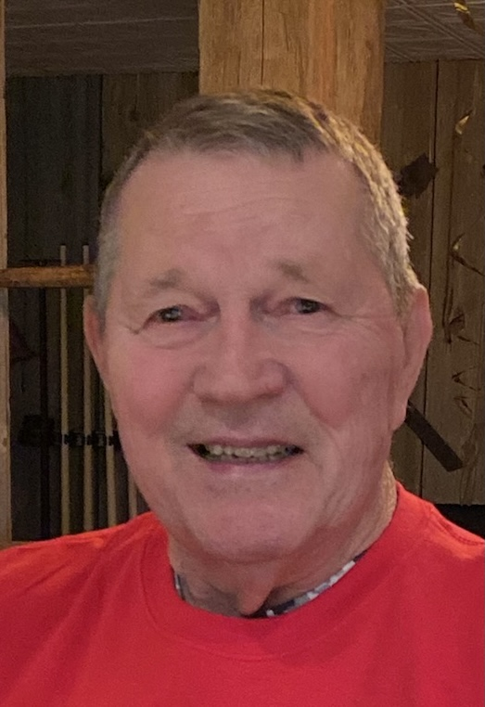

WHITEHOUSE STATION (Formerly of East Brunswick) - DONALD WIEDER passed away on Friday, November 6, 2020, surrounded by his beloved wife and family. He was 81 years old.
Don graduated from Pen Argyl Area High School and East Stroudsburg State College with a Master's Degree in Physical Education (PE). While as ESU, Don was a member of the touring gymnastics team. Following college, Don moved to East Brunswick and held several coaching positions. Don's real passion for coaching was gymnastics where he established the winningest gymnastics team in NJ. Under his tutelage, Coach Wieder's gymnasts won 16 state championships and earned 20 scholarships. He also operated Wieder's Gym Club for 14 years.
Don was known for his witty sayings and painful sidewinders. He loved coaching gymnastics and developing young men and women. Always a quiet and humble man, he worked hard, served others, and served his Lord on his church council. Nothing made him happier or smile harder than spending time with his children and 10 grandchildren. Don was very proud of his family.
Don is survived by his loving wife of 56 years, Estelle Smith Wieder, and his 4 loving children: Karin Capri and husband Mike of Emmaus, PA; Jay Wieder and his wife Rachel, of Whitehouse Station, NJ; Cathy Cieri and husband Mark of Flower Mound, TX; Alison Tedesco and husband Tony of Verona, NJ, and 10 grandchildren (7 "bums" and 3 "squirrels"), many nieces, nephews, gymnasts, and sister Fern Buss, and brothers Tom and Dennis Wieder.
Funeral services will be held on Wednesday, November 11, 2020, at 1:00 pm, at The BRUNSWICK MEMORIAL HOME, 454 Cranbury Road, East Brunswick. Interment will take place on Thursday, November 12, 2020 at 11:00am at Farmersville Cemetery, Easton, PA.
Family and friends may visit on Wednesday, November 11th, from 11:00 am to 1:00 pm at the funeral home. For directions please visit the 'Services' page.
In lieu of flowers please make a contribution to:
Fischer Center for Alzheimer's Research Foundation, https://www.alzinfo.org/
Samaritan's Purse, https://www.samaritanspurse.org/
Nativity Lutheran Church, 552 Ryders Lane, East Brunswick, NJ 08816

